Quick Start Guide

SENSORSHLD1-EVK-101 and the Arduino Uno

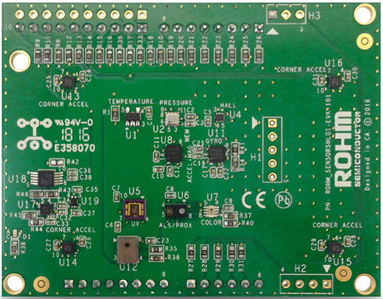

Above: Top view of ROHM SENSORSHLD1-EVK-101

04 May 2016, Revision A

# Introduction

The following document was written to provide a quick start guide for using the sensor shield with the Arduino Uno. Supplementary information including application examples and HW design files for this board can be found at the following repository link.

ROHM’s Multi-Sensor Shield GitHub Repository Page: <https://github.com/ROHMUSDC/ROHM_SensorPlatform_Multi-Sensor-Shield>

ROHM’s SENSORSHLD1-EVK-101 is a shield evaluation platform that connects all ROHM sensor products onto a single board. This shield uses standard Arduino shield interface pins; therefore, can connect to any evaluation kit that has a shield interface header. The shield contains the following sensors:

* Core Sensors:
  + ROHM BDE0600G – Analog Temperature Sensor
  + ROHM BM1383AGLV – Digital Barometric Pressure Sensor
  + ROHM BU52014HFV – Hall Switch Sensor (Omnipolar with Polarity Discrimination)
  + ROHM BM1422GMV – Magnetometer Sensor
  + KIONIX KX122 – Digital Accelerometer
  + KIONIX KMX62 – Digital Magnetometer and Accelerometer
  + KIONIX KXG03 – Digital Gyroscope and Accelerometer
  + LAPIS ML8511A – Analog UV Sensor
  + ROHM RPR-0521 – Digital Ambient Light Sensor and Proximity Sensor
  + ROHM BH1745 – Digital Color Sensor
* Special Functions:
  + KNOWLES SPM0423HD4H-WB – Digital Microphone
    - Primarily for use with NXP MCU Lineup
  + KIONIX KX122-1037, KX122-1048 – Accelerometer
    - For four corner Accelerometer algorithm development
    - Difference between 1037 and 1048 is the I2C register address scheme to control all 4 accelerometers using a single I2C master

# Environment Preparation and Evaluation

1. Prepare the Arduino Environment on your PC. If you already have a programmed Arduino board and reworked shield, skip to step 4a below.
   1. Additional details on preparing the Arduino environment can be found at the website linked here: <https://www.arduino.cc/en/Guide/Windows>
2. Preform the required HW rework for this shield board
   1. On the Arduino UNO board, please note that the I2C pins connected to the top left header are actually routed to pins A4 and A5 on the bottom right connector. This conflicts with the UV sensor’s ADC output already existing on the board. Thus, in order to reroute this on our board, we suggest the following rework…
      1. Disconnect existing nets by removing R27, R31
      2. Reconnect UV sensor ADC by connecting the top pad of R31 to the bottom pad of R27
   2. Picture Reference
      1. 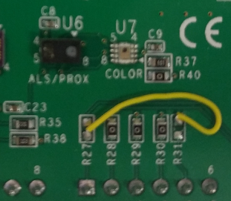
   3. Please note that multi-sensor shield board schematics can also be found at the following site:
      * 1. <https://github.com/ROHMUSDC/ROHM_SensorPlatform_Multi-Sensor-Shield>
3. Flash/Program the Arduino Board using the code found in the GitHub Repository for this Sensor Shield through the Arduino IDE Environment
   1. <https://github.com/ROHMUSDC/ROHM_SensorPlatform_Multi-Sensor-Shield>
      1. …/Platform Code/Arduino_UNO_FirmwareExample/
   2. NOTE: Additional information about HW setup and how to use the FW provided can be found in the platform guide for Arduino provided in the same folder above.
4. Finally, we want to see what the board is returning. If you have the Arduino IDE setup, we can see the return messages using the Arduino Serial Monitor.
   1. Alternatively, if you have an already programmed Arduino board and shield, you can use any generic COM port terminal to view the board output. For this example, we recommend TeraTerm.
      1. TeraTerm Download: <https://ttssh2.osdn.jp/index.html.en>
      2. TeraTerm Settings:
         1. Setup -> Serial Port
            1. 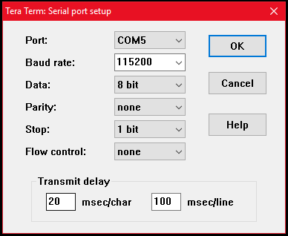
            2. NOTE: the PORT shown above will need to change to whatever COM port the Arduino UNO is connected to. This can be found using the device manager on the PC

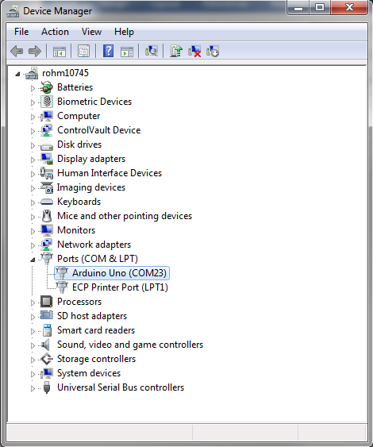

* + 1. After everything has been installed correctly, you should be able to open the serial port connection using “File -> New Connection” or the keyboard shortcut, Alt-N
       1. 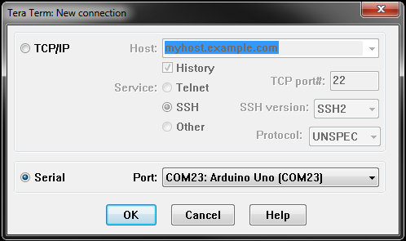
    2. Finally, the user can confirm the operation of the Arduino board and Sensor Shield by viewing the output of all the different sensors. When working correctly, the return messages should show in the terminal like the following:
       1. 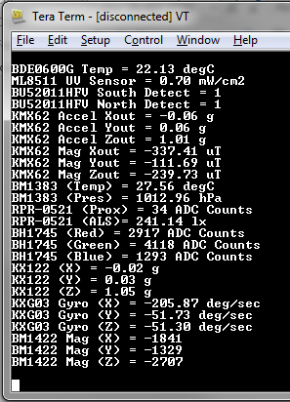
       2. NOTE: The Board will continually send back messages that contain the sensor output. There is no need for the user to input any key commands to generate output.